Recognized pattern: FakeTimer_variety1

The form of the pattern:

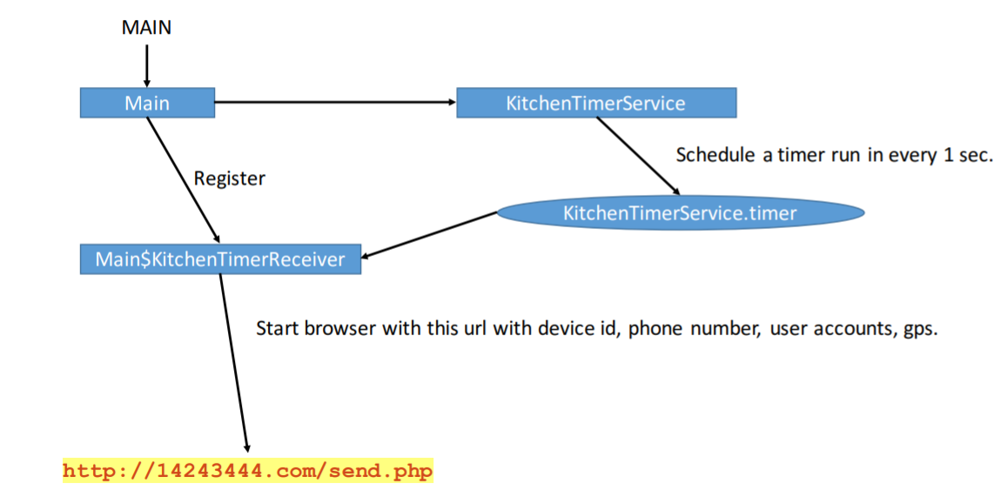

Name of Sample app:

The name of this app:

Transdroid

For functional modules

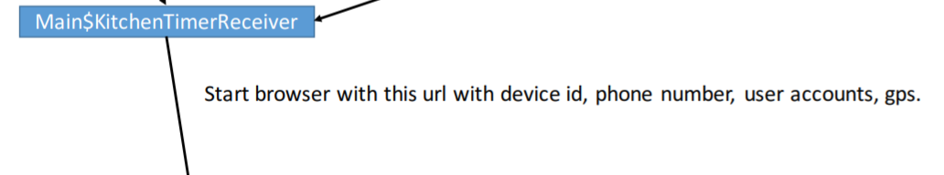

Corresponding to the key code in this app:

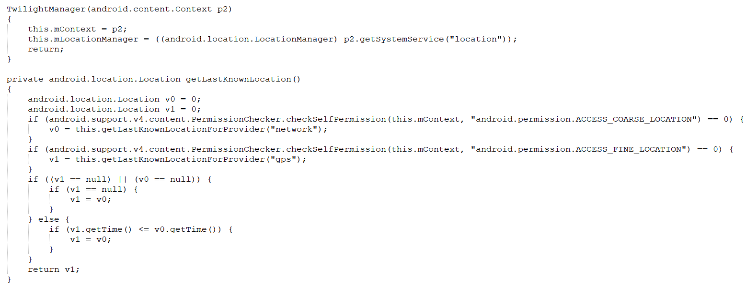

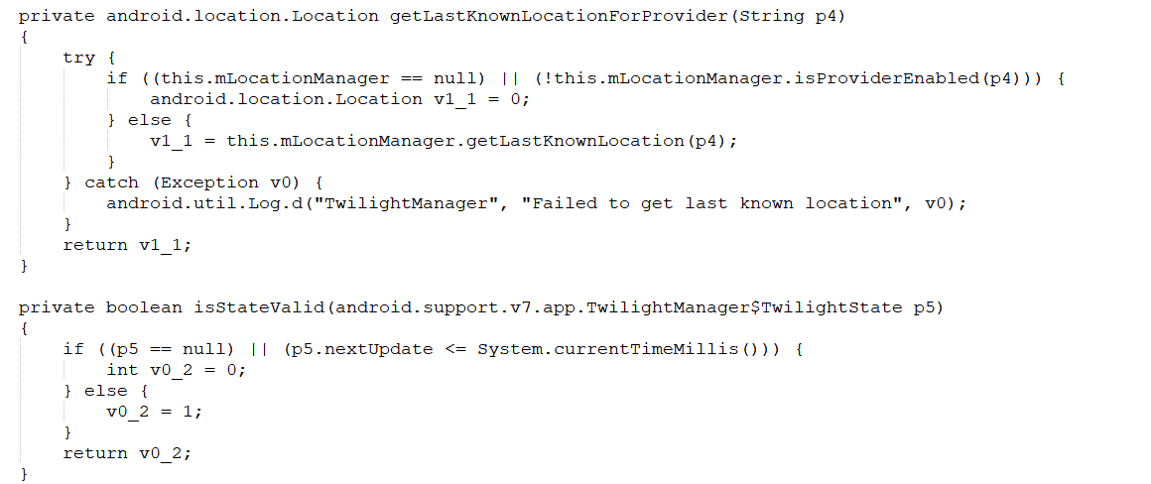

Corresponding to the key code in sample app:  
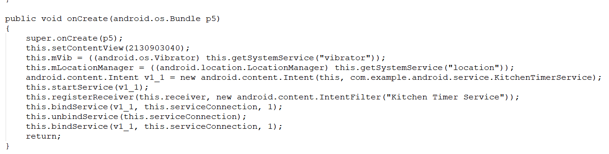

For functional modules:

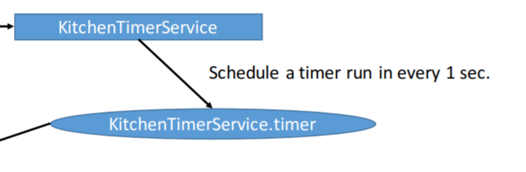

Corresponding to the key code in this app:

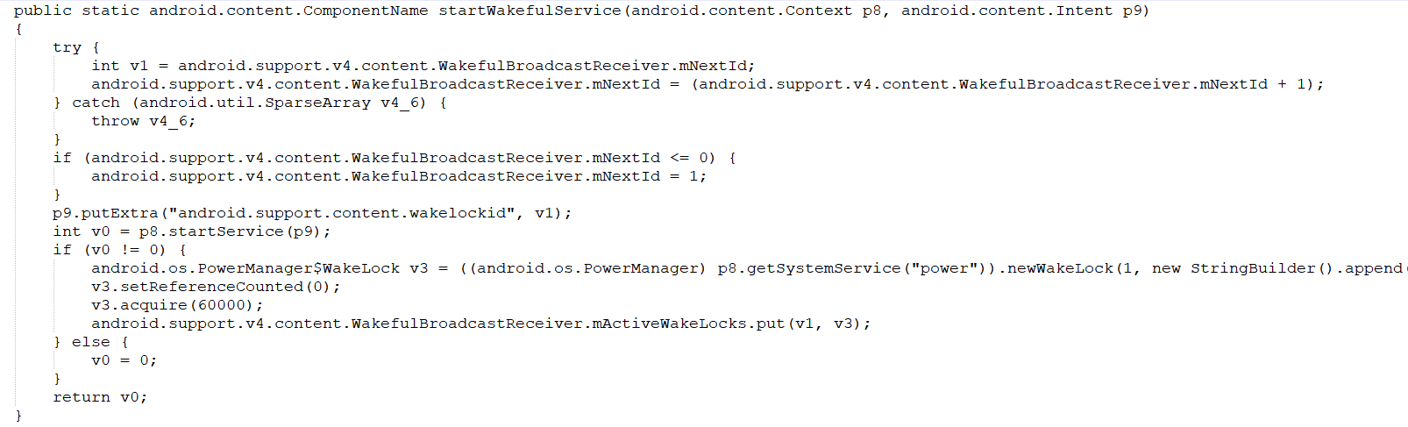

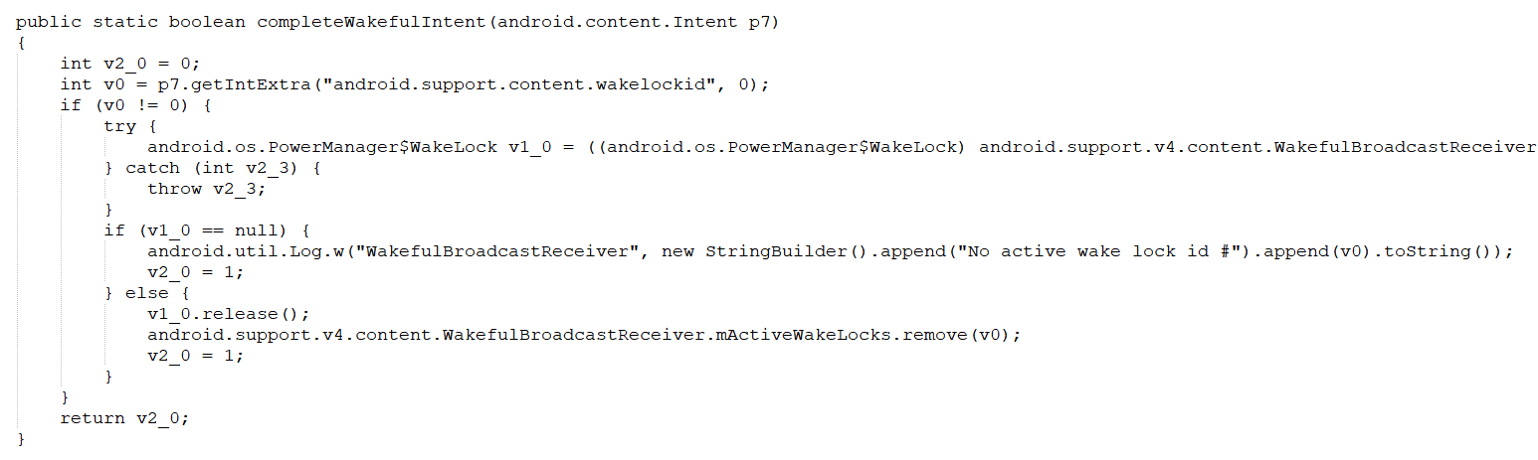

Corresponding to the key code in sample app:

